Seeing and Drawing Japanese Children’s Culture :

Cute, Robotic and Strange: Heroines, Heroes and Monsters

A morning workshop in for elementary school children looking at animation, comics (manga), learning Japanese words and letters and making Japanese-character style masks (kamen).

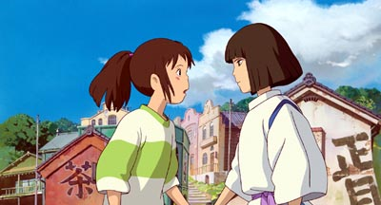Chihiro meets the bewitched boy, Haku, in Spirited Away

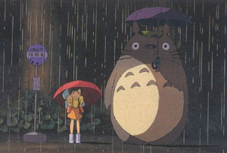 My Neighbour Totoro

This workshop will introduce elementary school children to the internationally acclaimed animated children’s films of Miyazaki Hayao. These whimsical and magical adventure stories are now considered amongst the best animation ever made. In the workshop we will look at My Neighbour Totoro (1988) and Spirited Away (2002, Oscar in 2003). They are adventure stories with an environmentalist twist, and a connection with folklore and with modern child heroines and heroes.

The workshop leader is Sharon Kinsella. She has written a book about Japanese comic artists and how comics are made in Japan. She has taught students in university and in secondary school in Japan, America and England. Parents can look at her website www.kinsellaresearch.com if they are interested to see any of her articles on girl culture and comics written for adults.

Workshop Plan

10.00-10.30am

Learn something about Japanese school children and their school lives. What they look like: their special leather book satchels and exercise books for writing ‘letters’ vertically.

Introduce our selves; choose a Japanese name and learn how to write it in Japanese letters (syllables); paint and draw our new Japanese name on large sheets. Leave some space to add some drawings later in the morning.

10.30-10.40am ** break** (some animation on in the back of the class?, comics to look at?)

10.40-11.10am

See a clip from Miyazaki’s Totoro. After watching it we will spend a few minutes talking about what we liked about it. Time to ruminate on the little girl heroine, or her animal friends, or her poorly mother, for example. We will learn how to speak, and maybe how to read and write some words like cute, child, cat, and monster. See projected images of some other cute characters and heroines. Tell the class about any other cute characters of superheroes we know from television. (Go Rangers, Sailormoon, Pokemon, Hello Kitty?) Did they come from Japan?

11.10-11.20 pm **break** (Japanese biscuits and sweets?)

11.20-11.50pm

See a clip from Miyazaki’s Spirited Away. Talk about what we liked about it: the brave girl Chihiro and how she sacrifices herself and her own first name for her parents. What are her parents like? What is the ghost world like? Ancient? Modern? Friendly or scarey? Why does Chihiro have to work so hard? See a clip from Sailormoon in which elementary schoolgirl Usagi receives ‘moon prism power’, and talk about the idea of child super-heroines and their special cute animal friends. Would we like to have special powers too? Can you imagine being friends with a Japanese girl who is secretly using super powers?

11.50-12 noon **break** (look at comics with speech bubbles - Mizuki?, on a projector? in English translation?)

12.10am-1pm

Children will spend the last session of the morning drawing a monster, animal, or a character that they found interesting in the animations they have seen, on a sheet of card or paper. Copying animated characters and inventing new animated characters is a popular pastime of Japanese school children. We can also draw into this picture a speech or a thought bubble, and use English or Japanese words, or both to make our character say something. If we like the imagination of Miyazaki Hayao we could also make the animals in our pictures talk, or give the trees and rivers their own thought bubbles!

If we have time, we can also draw the outlines of a mask to wear, based on our own invented Japanese-style character. Consider how mechanical, robotic, super-powered, and cute things are popular with Japanese school children. See some animated masks made in the 1950s in Japan.

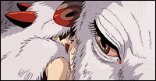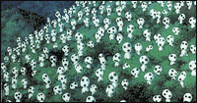
Princess Mononoke and the ancient forests

