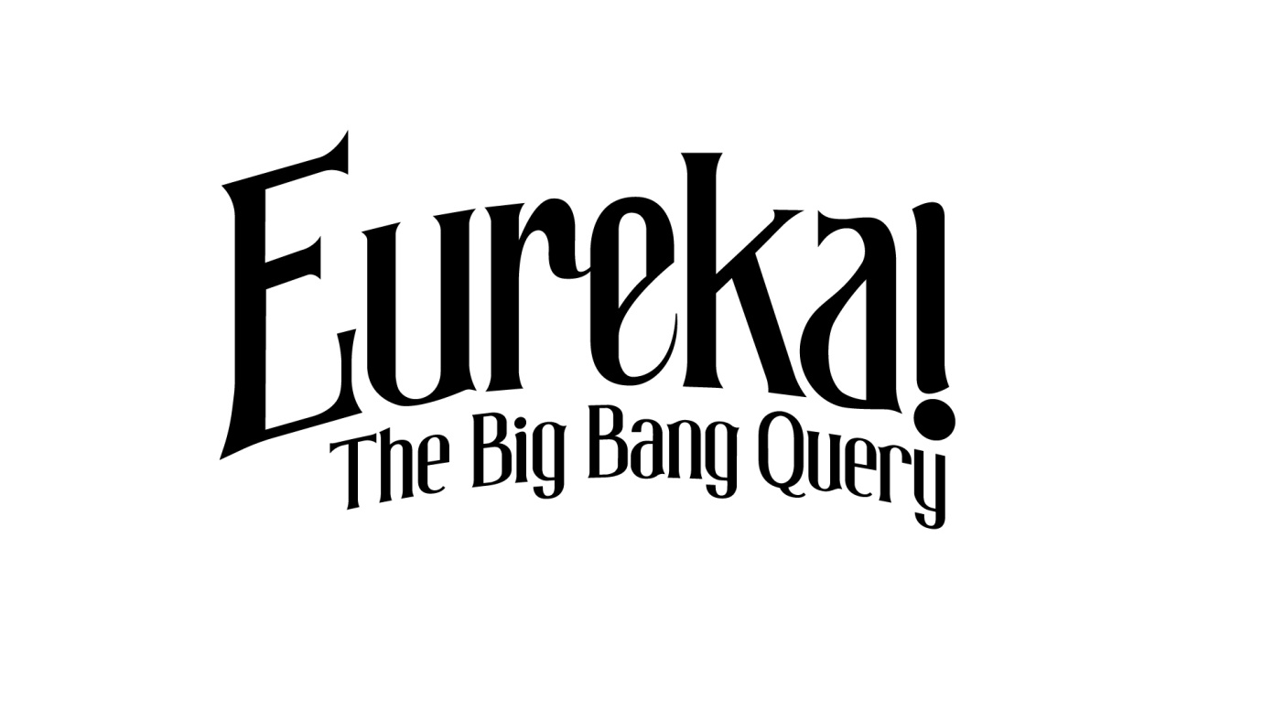‘Eureka! - The Big Bang Query’ is a brand new Comedy-Science panel show for RTÉ 2 television. It will see Neil Delamere bringing the sharpest wits in comedy and the finest minds in science together to discuss the world’s most fascinating discoveries, answer some age old questions about the universe and debate whether or not you can turn a Delorean into a time machine.
Team captains PJ Gallagher and Dr. Aoibhinn Ni Shúilleabháin will be joined by guest comedians and science personalities for each show.
Recordings will take place in the old John Player Factory in Dublin 8 with recordings taking place on Monday 25th, Tues 26th, Wed 27th, Thurs 28th and Friday 29th of January with two shows being recorded each evening.
If you would you like to be part of the Studio Audience then please email us at tickets@mindthegapfilms.com by Wednesday the 18th of January for further information.
Applicants must be over 18 as wine will be served on the night.

