DCU Engineering Society – Robot Wars

Proposed Plan:
The idea behind this is based on a challenge found online by an American company called Sparkfun Electronics. Reference: http://www.sparkfun.com/. It contains the basic idea of battling R/C vehicles one to one in an enclosed space. They have blog showing an advanced version of our proposed idea. Reference: http://www.sparkfun.com/news/857. We hope to do a similar job on a similar scale either to a similar or simpler standard.

Our Aim/Outcome:
Our aim is to involve our society in a group based challenge, currently for any DCU Eng. Soc. member, with an aided learning and building project that will be both for fun and as an educational experience. Below is a simple ideal outcome for the challenge:
- Build the arena with self made traps and pit falls.
- Build the R/C vehicles.

Estimated time and cost:
We predict that the project will be completed over the two semesters. In the first semester it is planned that the arena is to be built as a warm-up exercise to allow the competitors know how to best design their vehicles. The vehicles will then be designed as a group before the end of semester one, upon returning to college for semester two we hope that a complete parts list will be compiled by the competitors.
The cost is one issue that will be closely watched as we know that the more money invested can increase in the hopes of winning, so as a way of controlling that the competition runners will order the parts to ensure our estimated cost limit is not exceeded. Our cost limit (for the moment) is €50 per vehicle entered. We hope that this includes all the cost of the materials including the expensive radio communication devices (We hope to consult the engineering faculty for more guidance in this area due to their experience in building similar projects). The cost of the arena is dependent on what finance is available

Rules:
Some of the proposed rules are shown below:
- Size limit to not exceed 2100mm by 2100mm (i.e. as wide as an A4 sheet ).
- A weight limit per vehicle of 0.8-1kg.
- Weponary: Open to ideas, but limited by the following two rules below:
  - No pyrotechnics (fire, fireworks etc.)
  - No projectiles
- Defensive ideas have no limit but are to follow the same restrictions as in 3a and 3b above.
- Cost of vehicle must not exceed €50
- Teams can not exceed 5 people. Ideally around 3-4 people is advised so as to share work load

Sources of finance:
There are a few options for sourcing of finance:
- Using money allocated to us by the CLC.
- Ask the Engineering Faculty
- Ask Engineers Ireland (Supported similar ideas run by IT Blanchetown.) Money was used to buy prizes. Reference: http://b00002332.wix.com/robochallenge.
- Rely on the competitors for complete financing of the project.

Materials Allowed to be used (Allow for revision):
*Note materials were research via the web and prices can change with time/ availability

Chassis:
- Aluminium – researched cost (120mm*254mm*4.1mm) is €2.34
- Acrylic – No current researched cost as of yet as waiting for quote
- Expanded PVC Sheet – (297mm*197mm*2mm) €2.88 (Cheaper in bulk)

Robot:
- R/C receiver (need assistance in which is best to use and cheapest/easiest)
- Motors/Servos/Stepper motors
- Solenoids
- Battery
- Any other equipment required by the teams as long as within the stated rules above

“War Zone” Arena (Price dependent, all options stated):
- Plywood
- Acrylic
- Frame (3m*50mm*35mm est. cost €1.70)

Arena:
The arena is going to be 2.1m*2.1m with a construction of a timber frame and either a ply sheet or acrylic sheet. If the acrylic version is picked the tiles would measure 30cm*30cm. This would be similar for the plywood but would be thicker than the acrylic

Sample of Pictures:
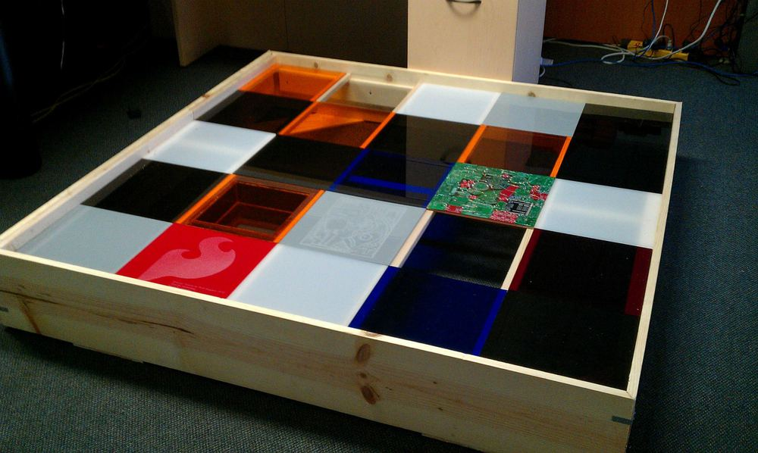
Figure 1. Proposed Arena using Acrylic tiles
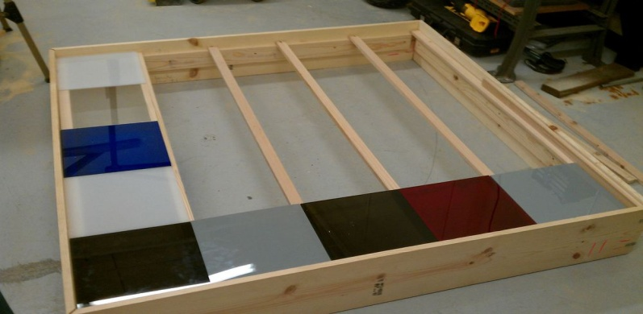
Figure 2. Proposed Idea for construction
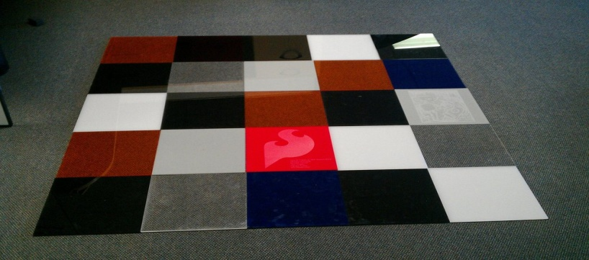
Figure 3. Propesed floor design

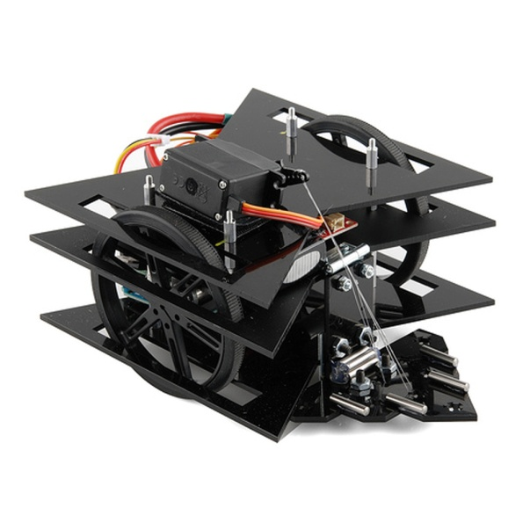
Figure 4. An idea of what we hope to achieve.
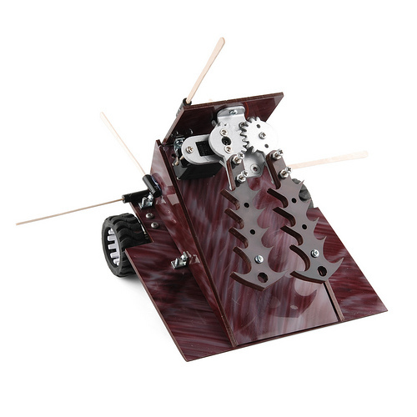
Figure 5. Another idea
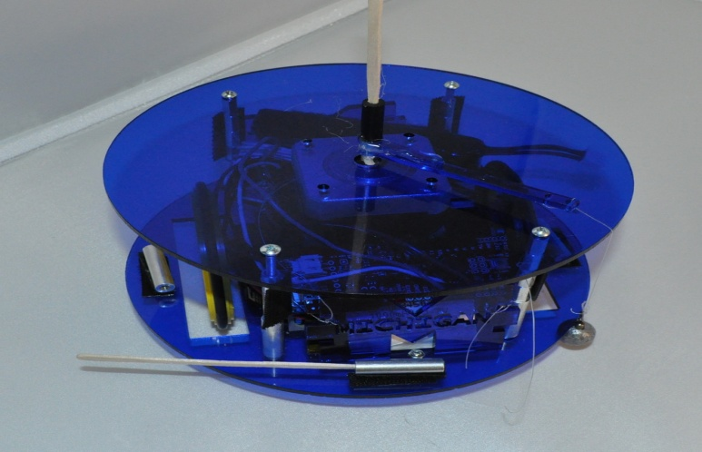
Figure 6. Another idea

